# **Name: Abdurrahman Qureshi**

# **Roll No: 210451**

Practical No: 11

1) Write a Python script to Function to check if a number is prime

CODE:

def is_prime(num):  
 if num <= 1:  
 return False  
 elif num == 2:  
 return True  
 elif num % 2 == 0:  
 return False  
 else:  
 for i in range(3, int(num**0.5) + 1, 2):  
 if num % i == 0:  
 return False  
 return True  
  
number = 17  
if is_prime(number):  
 print(number, "is prime")  
else:  
 print(number, "is not prime")

OUTPUT:

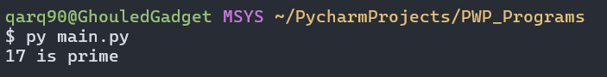

2) Program to calculate the factorial of a number

**CODE:**

def factorial(n):  
 if n == 0:  
 return 1  
 else:  
 return n * factorial(n - 1)  
  
number = 5  
print("Factorial of", number, "is", factorial(number))

**OUTPUT:**

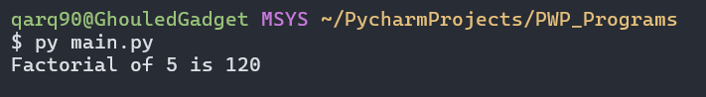

3) Function to calculate the number of upper case and lower case letters in a string

**CODE:**

def count_upper_lower(string):  
 upper_count = sum(1 for char in string if char.isupper())  
 lower_count = sum(1 for char in string if char.islower())  
 return upper_count, lower_count  
  
input_string = "I love Gym Mommies!"  
upper, lower = count_upper_lower(input_string)  
print("Number of uppercase letters:", upper)  
print("Number of lowercase letters:", lower)

**OUTPUT:**

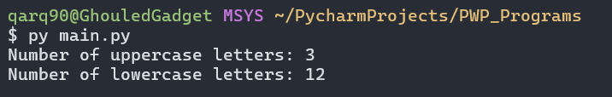

EXTRA QUESTIONS

4) Program to check whether a string is palindrome or not

**CODE:**

def is_palindrome(string):

return string == string[::-1]

input_string = "radar"

if is_palindrome(input_string):

print(input_string, "is a palindrome")

else:

print(input_string, "is not a palindrome")

**OUTPUT:**

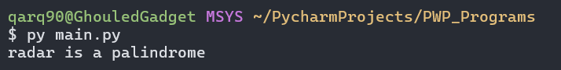

5) Program to calculate LCM (Least Common Multiple) and GCD (Greatest Common Divisor) of two non-negative integers.

**CODE:**

def gcd(a, b):  
 while b:  
 a, b = b, a % b  
 return a  
  
def lcm(a, b):  
 return (a * b) // gcd(a, b)  
  
num1, num2 = 12, 18  
print("LCM of", num1, "and", num2, "is:", lcm(num1, num2))  
print("GCD of", num1, "and", num2, "is:", gcd(num1, num2))

**OUTPUT:**

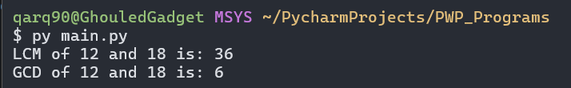

6) Program to convert a given decimal number to binary

**CODE:**

def decimal_to_binary(decimal):  
 return bin(decimal).replace("0b", "")  
decimal_number = 10  
print("Binary representation of", decimal_number, "is:", decimal_to_binary(decimal_number))

**OUTPUT:**

